FAIR Technology Matrix - User Guide

Peter Wittenburg (GEDE), Kristina Hettne (LUMC, GOFAIR)

This document helps to fill in the questionnaire called FAIR Technology Matrix. We hope that the usage of the wizard is straightforward. Use a normal browser and open the site

**https://gede.ds-wizard.org/**

This screen should appear. For the credentials ask Zsuzsanna or Peter.

In this second test phase we still want to use one account for the different contributions. In future we may want to change that which would require a separate registration step.

Once logged-in, the following screen should appear.

You select first "Questionnaire".

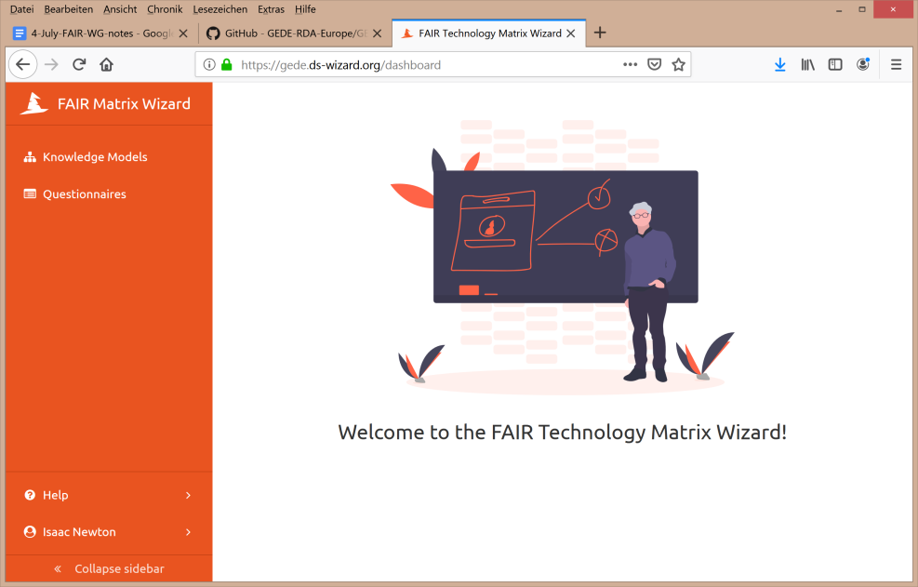

Once "Questionnaire" was selected you should see the following screen offering you the choice to look at already filled questionnaires or create a new one. As owner you can start filling in your questionnaire and continue/change answers at a later moment.

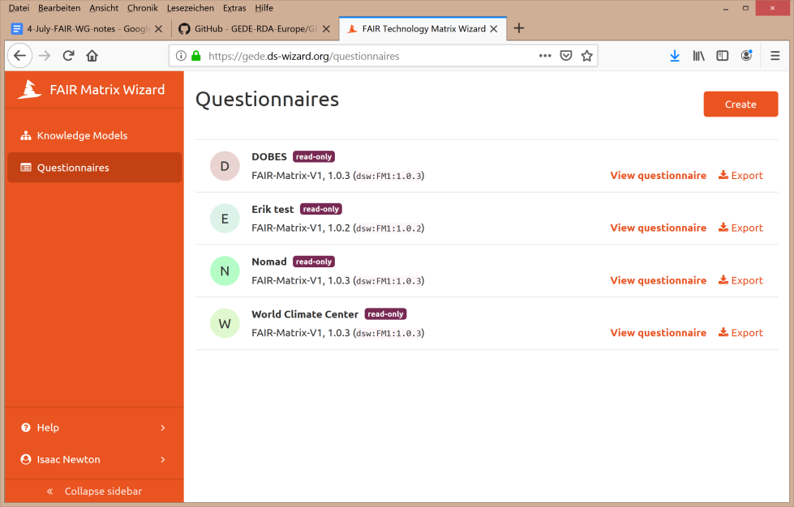It shows you already filled in questionnaires which are available for read access. We did this on purpose so that you can see what other colleagues filled in already and how thy interpreted the questions. So you can select one of these existing questionnaires and study the answers. You could in fact open two browser windows - one showing an existing response and the other showing your questionnaire. You could also export a given questionnaire for example as a PDF document.

**Finally, you click on the Create button which opens a questionnaire instance where you can add your answers. Don't write into existing questionnaires from others even if they are allowed to be changed.**

Once the Create button pressed, the following screen should appear.

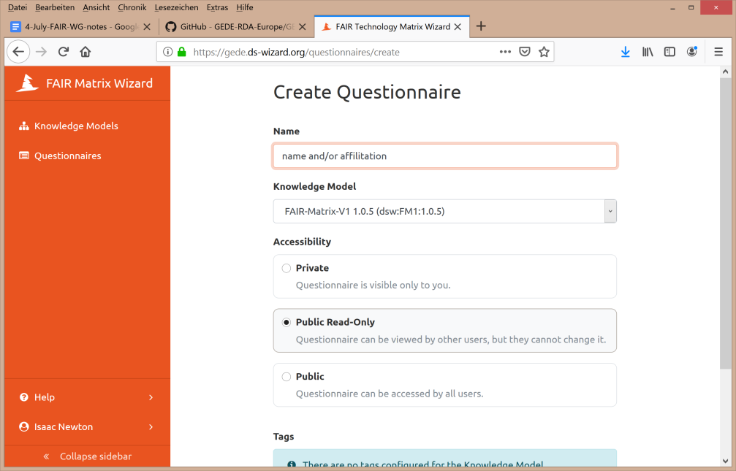Please, add name and/or affiliation so that we can quickly recognise which questionnaire it is.

Then select the Knowledge Model:

**FAIR-Matrix-V1 1.0.5**

We recommend to select the **Public Read-Only** option allowing also experts with other credentials to read the answers and to enable analysis. We, Kristina and Peter, have management rights which means that for analysis purposes we can read these questionnaires. Then press thee SAVE button which is not on the screenshot.

This then opens the questionnaire for you and you are ready to input your answers. The following two slides give an impression about the structure of the questionnaire.

* It has 11 **sections** dedicated to specific clusters of questions starting with some general information about the survey and the questions about the person answering the questions.
* Each section has a number of **questions** and an **introductory text**.
* Each question has an **introductory text**, an **explanation,** and where possible a link to the corresponding FAIR principle and a **vocabulary**.
* We expect much prose text, however, would prefer to see as much as possible "formal" answers and where possible links.

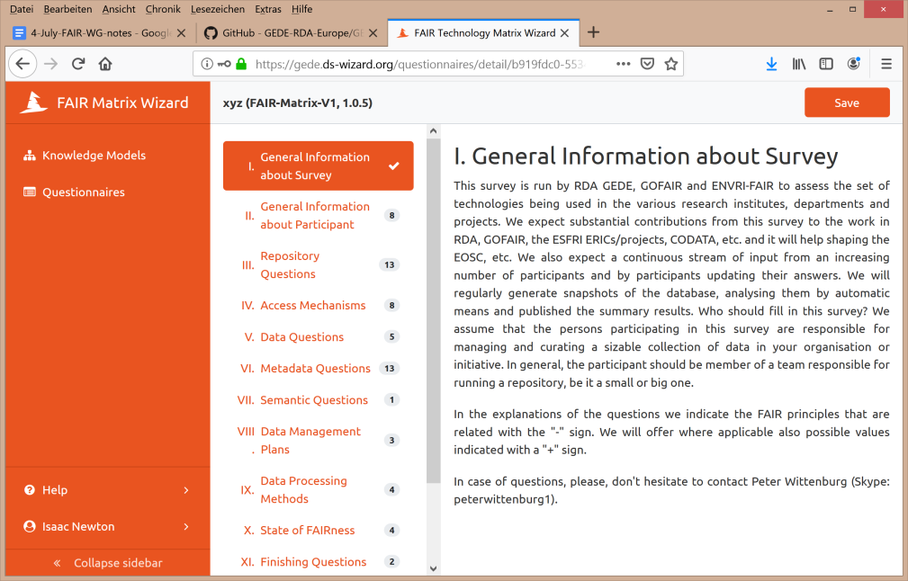

Whenever you entered answers to a section do not forget to press save.

You can stop and start later again adding new answers or changing old ones.

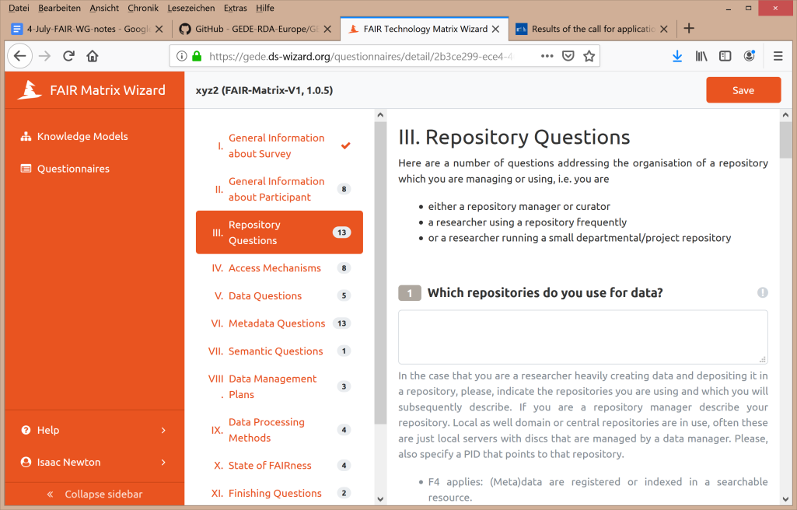

We very much appreciate your participation and as 5 years ago we expect quite some impact from this state of technology survey. It is obvious that also the EOSC process is very much interested in these results. Please finish your questionnaire until end August

In case of questions, do not hesitate to call Peter Wittenburg either by mobile phone (+49 15141858784) or by skype (peterwittenburg1).